Section 5: The Compact Singular Value Decomposition, Least-Squares, and Linear Models.

This section is meant to be read in conjunction with Sections 7.4 and 6.5-6 of Lay's text.

The Compact Singular Value Decomposition
We begin with some simple propositions.

Proposition 5.1: Let A be any matrix. Then AA^{T} and A^{T}A are both positive semidefinite symmetric matrices.

Proof: The symmetry of both AA^{T} and A^{T}A is immediate from the multiplication rule for the transpose. Now let v be any vector. Then v^{T}AA^{T}v = A^{T}v • A^{T}v ≥ 0. This shows that AA^{T} is positive semidefinite, and a similar argument shows the same for A^{T}A.

Proposition 5.2: If v₁ and v₂ are orthogonal eigenvectors of A^{T}A, then Av₁ and Av₂ are orthogonal.

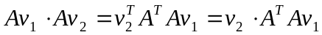, but the last term on the left is a multiple of 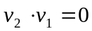, since v₁ is an eigenvector of A^{T}A .

The idea of the compact singular value decomposition for the mxn matrix A is as follows. We start by finding an orthogonal nxn matrix V that diagonalizes the symmetric nxn matrix A^{T}A. We want the columns of V ordered so that earlier columns correspond to larger eigenvalues of A^{T}A. It follows from Proposition 5.2 that the columns of AV are orthogonal. Moreover, the non-zero columns form a basis for the column space of A. We obtain U by normalizing the non-0 columns of AV, and discarding the others. We observe, incidentally that if v_{i} is the i^{th} column of V, then 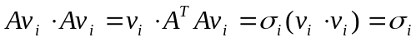, where 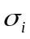 denotes the i^{th} eigenvalue of A^{T}A, taken in descending order. It follows that the i^{th} column of AV has length s_{i}=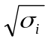 Then if we write for the diagonal matrix whose i^{th} entry is 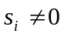 , and we obtain V_{r} by deleting those columns of V that correspond to 0 as an eigenvalue of A^{T}A, we have, AV_{r}=U. V_{r}=V, then we know that V_{r} V_{r} ^{T} is an identity matrix, so that A=UV_{r} ^{T}. However if V is no longer square, it is no longer the case that V_{r} V_{r} ^{T} is an identity matrix. What rescues us is the following proposition.

Proposition 5.3: If the matrix V has orthonormal columns, then, for any vector w, V V^{T} w is the orthogonal projection of w onto the column space of V.

Proof: V^{T}V is an identity matrix, so that VV^{T}V=V. It follows that if w is any linear combination of columns of V, then VV^{T}w=w. Furthermore, if w is orthogonal to all the columns of V it follows that V^{T}w=0 so that VV^{T}w=0. The result follows.

With V_{r} as in the previous paragraph, the columns of V_{r} form an orthonormal basis for the orthogonal complement of the nullspace of A . It follows that if w is orthogonal to the nullspace of A, then
AV_{r}V_{r} ^{T}w=Aw, while if w is in the nullspace of A, it follows that both Aw and AV_{r}V_{r} ^{T}w are 0. It follows from orthogonal decomposition with respect to the null space of A that AV_{r}V_{r} ^{T}w=Aw in all cases, so that AV_{r}V_{r} ^{T}=A. and hence that A=UV_{r} ^{T}. This is known as the compact singular value decomposition of A.

We illustrate with an example.

A=[1 2 3;4 5 9;6 7 13;1 5 6; 2 2 4]

A =
1 2 3
4 5 9
6 7 13
1 5 6
2 2 4

Since A is a 5x3 matrix, AA^{T} will be 5x5, and A^{T}A will be 3x3. We compute eigenvalues and eigenvectors for A^{T}A.

[V,D]=eig(A'*A)

V =
-0.7416 0.5774 0.3417
0.6667 0.5774 0.4714
-0.0749 -0.5774 0.8131
D =
5.5930 0 0
0 -0.0000 0
0 0 470.4070

One of the eigenvalues appears to be 0, but let us make sure.

format long
eig(A'*A)
format short

ans =
1.0e+002 *
0.05593029364436
-0.00000000000000
4.70406970635564

It now looks safe to assume that the second eigenvalue is 0. For the singular value decomposition, we will want the eigenvalues to appear in size places with the largest eigenvalue at the upper left. Moreover we will retain only the non-0 eigenvalues and the corresponding columns. We redefine D and V accordingly.
V=[V(1:3,3) V(1:3,1)]

V =
0.3417 -0.7416
0.4714 0.6667
0.8131 -0.0749

D
D=diag([D(3,3),D(1,1)])

D =
470.4070 0
0 5.5930

S=sqrt(D)

S =
21.6889 0
0 2.3650

U=A*V*S^(-1)

U =
0.1717 0.1553
0.5091 -0.1296
0.7340 -0.3195
0.3493 0.9061
0.2249 -0.1899

U*S*V'-A

ans =
1.0e-014 *
-0.1110 -0.1554 0.1332
0.0888 -0.0888 0.3553
0 -0.2665 -0.1776
-0.4885 -0.6217 0.5329
0.0444 0 0

Let us compare the singular value decomposition we have produced with the one returned by MATLAB

[Um,Sm,Vm]=svd(A)

Um =
0.1717 0.1553 -0.9468 -0.2228 -0.0165
0.5091 -0.1296 -0.1189 0.8211 -0.1888
0.7340 -0.3195 0.2074 -0.5230 -0.2066
0.3493 0.9061 0.2146 -0.0188 0.1030
0.2249 -0.1899 -0.0182 0.0474 0.9543
Sm =
21.6889 0 0
0 2.3650 0
0 0 0.0000
0 0 0
0 0 0
Vm =
0.3417 -0.7416 0.5774
0.4714 0.6667 0.5774
0.8131 -0.0749 -0.5774

Our U and V agree to the four places shown with the first two columns of Um and Vm respectively, as do the non-zero entries of S and Sm. Let see how A compares with UmSmVm^{T}.

Um*Sm*Vm'-A

ans =
1.0e-014 *
0.1110 0.4441 0.6661
0.1776 0.2665 0.3553

0.2665 0.4441 0.7105Pro
-0.0111 0.2665 0.1776
0.0444 0.0888 0.1776

The order of magnitude of the difference is the same as with the decomposition we constructed, but we can see that they are not exactly the same; this is not surprising since we used a different algorithm.

Pseudo-inverses and Least-Squares

An important application of the compact singular value decomposition is that it enables us to construct the Moore-Penrose inverse (or pseudo-inverse) of any matrix A. To understand what this means, we consider the matrix equation Ax=b. If A is invertible, then we have x=A⁻¹b. However, if A is not invertible, then there may be no solution (or many solutions). If A has the compact singular value decomposition, UV^{T}, then the pseudo-inverse of A is defined as A⁺=V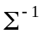U^{T}.

Proposition 5.4: A⁺ has the following properties:

If A is invertible, then A⁺=A⁻¹

AA⁺ is orthogonal projection on the column space of A.

A⁺A is orthogonal projection on orthogonal complement of the nullspace of A.

A⁺⁺=A.

For any vector b, b-AA⁺b is orthogonal to the column space of A and A⁺b is orthogonal to the nullspace of A.

Proof: We begin with the proof of 2. Since the matrices U and V that occur in the singular value decomposition of A have orthonormal columns, it follows that U^{T}U and V^{T}V are identity matrices. From this, it follows that AA⁺=UU^{T}. By Proposition 5.3, UU^{T} is orthogonal projection on the column space of A, but the column space of U is the column space of A., and 2. is proved. 3 is proved similarly; A⁺A=VV⁺, which is orthogonal projection on the column space of V. But the column space of V is the orthogonal complement of the null space of A. As regards 5., the first assertion folows from 2, and the second from the fact that A⁺b=V(U^{T}b) is in the column space of V. If A is invertible, then the column space of A is all of R^{n}. It follows from 5. that AA⁺b=b for all b and hence that AA⁺ is an identity matrix I. From the fact that A is invertible, it follows that A⁺ =A⁻¹AA⁺=A⁻¹I=A⁻¹. This establishes 1. 4 is a little tricky. The problem is that the factorization of A⁺ provided by its definition is not quite a singular value decomposition because the eigenvalues occur in the wrong order along the diagonal. In order to obtain a singular value decomposition, we must reverse the order of the diagonal entries of , reverse the order of the columns of V, and reverse the order of the rows of U^{T}. If P is the symmetric matrix with ones along the lower left to upper right diagonal and zeroes elsewhere, then we have P²=I and the desired singular value decomposition of A⁺ is given by (VP)(PP)(PU), and it now follows easily that A⁺⁺=A.

If Ax₀ is the projection of b on the column space of A, x₀ is called a least-squares solution of the equation Ax=b, and Ax₀ -b is called the least-squares error.

Proposition 5.5: A⁺b is the shortest least-squares solution of the equation Ax=b.

Proof: Suppose w is another least squares solution. Then w-A⁺b = y is in the null space of A, and
w = A⁺b + y.
By clause 5 of Proposition 5.4, y is orthogonal to A⁺b. It follows that ||w||² =||A⁺b||² + ||y||², and therefore w is longer than A⁺b.

Linear Models

The general linear model problem can be formulated as follows: Two quantities of interest, say x and y, are related by some function through which x depends on y. The function is not known, but can be shown, or is conjectured, to be a linear combination of several specific functions. The problem is to find the appropriate coefficients, based on a set of observations of x and y.

An example will make things clear. Suppose y is conjectured to be a quadratic function of x, so that y=f(x)=ax²+bx+c. Differently put, f(x) is a linear combination of the three functions x², x, and 1 with respective coefficients a, b and c. We have the following set of observations of (x,y): (1.2,1.4), (2.3,12.3), (3.3,26.7), (5.2,64.7), (7.1,117), (8.7,172.6), (9.3,196). We first prepare column vectors containing the x and y observations in corresponding positions:

X=[1.2,2.3,3.3,5.2,7.1,8.7,9.3]'
Y=[1.4,12.3,26.7,64.7,117,172.6,196]'

X =
1.2000
2.3000
3.3000
5.2000
7.1000
8.7000
9.3000
Y =
1.4000
12.3000
26.7000
64.7000
117.0000
172.6000
196.0000

Next, we prepare a matrix A, each of whose columns consists of one of the given functions (in this case 1,x, and x^2) evaluated at each of the x observations.

A=[ones(size(X)),X,X.^2]

A =
1.0000 1.2000 1.4400
1.0000 2.3000 5.2900
1.0000 3.3000 10.8900
1.0000 5.2000 27.0400
1.0000 7.1000 50.4100
1.0000 8.7000 75.6900
1.0000 9.3000 86.4900
Look carefully at the syntax of this command. The first entry produces an array of ones having the same shape as X. The last entry is not X^2 (which would return an error message because the matrix product X^2 is not defined) but X.^2, which instructs MATLAB to perform the squaring observation on each individual entry of X. At this point, our undetermined coefficients, should satisfy the matrix equation 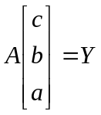 We seek a least squares solution to this equation. We use a modification of the svd command which produces a smaller singular value decomposition, although not always the compact one. (S will always be square, but some of the diagonal entries may be 0.)

[U,S,V]=svd(A,0)

U =
0.0122 -0.3269 0.7729
0.0427 -0.4630 0.2767
0.0864 -0.5265 -0.0584
0.2115 -0.4893 -0.3906
0.3919 -0.2452 -0.3238
0.5865 0.1207 0.0419
0.6696 0.2958 0.2520
S =
129.9150 0 0
0 4.0534 0
0 0 0.6238
V =
0.0154 -0.4032 0.9150
0.1202 -0.9077 -0.4020
0.9926 0.1161 0.0345

coeff=V*S^(-1)*U'*Y

coeff =
-5.0850
2.9923
2.0030

This gives a=2.003, b=2.9923, c=-5.085. Lets see how close a fit we have by checking the least squares error.

A*coeff-Y

ans =
-0.0098
0.0934
-0.0973
-0.0630
0.1333
-0.0424
-0.0142

Pretty good, considering the size of the entries of Y.

We will now consider the problem of fitting a more general quadratic curve to a large data set. We have stored our data in the column vectors X1 and Y1, which can be retrieved by loading the workspace quadratic.mat. You will need to download quadratic.mat, and place it in the same directory as your m-files.

load quadratic.mat

We can now work with the column vectors X1 and Y1. The following command plots the data points as dots, rather than as a connected curve. This is particularly important if the points cannot be expected to lie in any particular order along the curve.

plot(X1,Y1,'.')

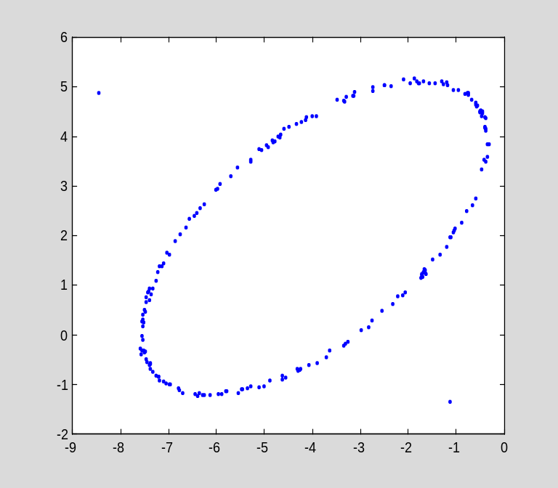

It certainly appears that these points lie along an ellipse, except for two outliers. If we can identify the outliers, we can eliminate them. We prepare a vector of numerals. The command text will now place the number of each point at the corresponding location.

size(X1)

ans =
200 1

Z1=num2str((1:200)');
text(X1,Y1,Z1)

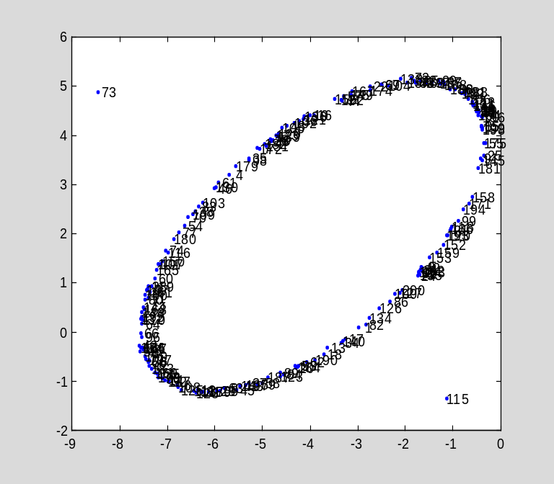

We can now see that the outliers are points 73 and 115 out of 200. We delete these :

X1=[X1(1:72);X1(74:114);X1(116:200)];
Y1=[Y1(1:72);Y1(74:114);Y1(116:200)];

Let us now try to determine an equation for the ellipse, using a modification of the least squares method. We begin by observing that every quadratic function of x and y is a linear combination of the functions 1,x,y,x²,xy and y². We prepare a matrix whose columns correspond to these functions, evaluated at the data points.

A=[ones(size(X1)),X1,Y1,X1.^2,X1.*Y1,Y1.^2];

Notice the .^ and .*. These direct MATLAB to evaluate the product and exponential separately in each position of the array, rather than to attempt matrix multiplication or expontiation, which would be undefined in this context and produce an error message. Also, the trailing semicolon is essential to suppress the printing of the huge matrix A.

Next, we look at the eigenvalue decomposition of the 6x6 matrix A^{T}A.

[V,S]=eig(A'*A)

V =
-0.3504 -0.4158 -0.8375 -0.0360 -0.0314 0.0241
0.9113 -0.0077 -0.3832 0.0103 0.0266 -0.1481
0.1624 -0.8882 0.3818 -0.0175 -0.1957 0.0212
0.1399 0.0021 -0.0361 -0.0183 0.1440 0.9788
0.0021 -0.0703 0.0504 -0.8648 0.4870 -0.0861
0.0294 0.1823 -0.0468 -0.5001 -0.8379 0.1076
S =
1.0e+005 *
0.0014 0 0 0 0 0
0 0.0007 0 0 0 0
0 0 0.0000 0 0 0
0 0 0 0.0702 0 0
0 0 0 0 0.4149 0
0 0 0 0 0 2.0462

We note that the third eigenvalue is the smallest. Let us see how small it actually is.

S(3,3)

ans =
0.0079

We will take the corresponding column of V for our coefficient array.

coeff=V(1:6,3)

coeff =
-0.8375
-0.3832
0.3818
-0.0361
0.0504
-0.0468

We can now define our quadratic function.

syms x y
f=[1,x,y,x^2,x*y,y^2]*coeff

f =
-471471078366929/562949953421312-6902345221602265/18014398509481984*x+3438687666718735/9007199254740992*y-5195919742018199/144115188075855872*x^2+1815801336529067/36028797018963968*x*y-6750192077768309/144115188075855872*y^2

For some reason, MATLAB insists on presenting the coefficients as rational numbers. No matter. Let us graph f and compare it to the original curve. We will use the m-file genplot, which is accessible along with the other course m-files on the course website. Our original plot showed X1 taking values between -4 and 4, while Y1 takes values between -3 and 7.

plot(X1,Y1,'.')
hold on
genplot(f,-4:.02:4,-3:.02:7,'contour',[0,0],'r')
hold off

The second and third arguments to genplot give the range and stepsize for x and y, respectively. The smaller the stepsize, the smoother the plot. The fourth argument causes a contour plot, and the fifth selects the contour corresponding to the value f=0. The last argument causes the contour to be plotted in red, so that we can see it together with the original dot plot. Clearly the fit is pretty close.

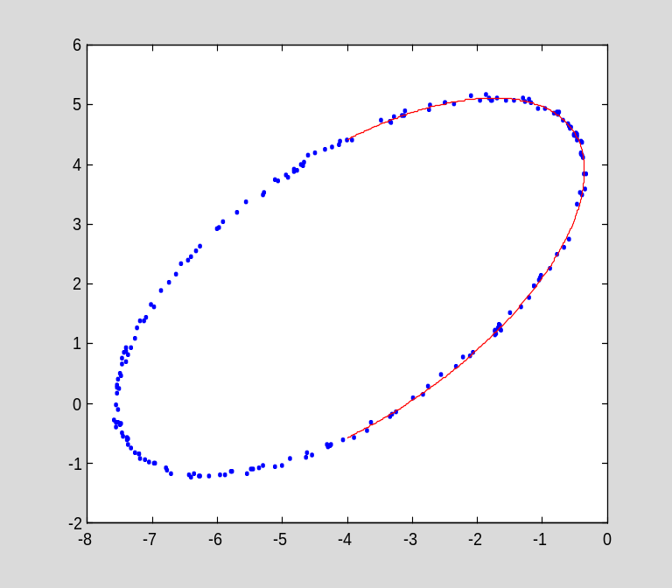

Problems:

- Solve Problems 15 and 16 in Section 7.4 of Lay's text.
- Solve Problems 26-29 in Section 7.4 of Lay's text. As in the example above, use the MATLAB command eig on a suitable symmetric matrix to obtain a compact singular value decomposition, and use the svd command only to check your work.
- Solve Supplementary Exercises 15 and 16 from Chapter 7 of Lay's text.

- Use compact singular value decompositions and pseudo-inverses to solve Problems 4-6, 8 and 11-12 of Section 6.5 of Lay's text.
- Solve Problems 10-13 of Section 6.6 of Lay's text.
- Find the best fit quadratic curve through the set of points whose coordinates are stored as X2 and Y2 in the workspace quadratic.mat
- See what happens if you try to find the best fit quadratic curve in problem 8 without first eliminating the outlying points. (You can either do this before problem 8 or you can recover the original X2 and Y2 by reloading quadratic.mat.)

